Schoolinks Step By Step Guide

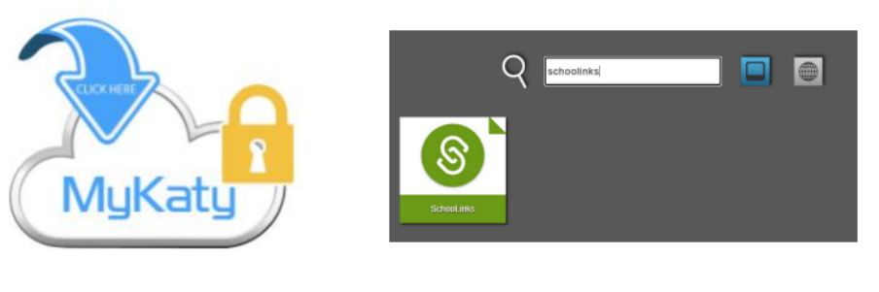
The student will sign into MyKatyCloud and search “Schoolinks”
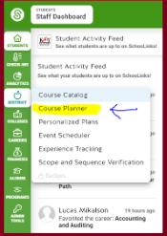
Choose the apple icon on the left side labeled “school”. Then choose “Course Planner” .
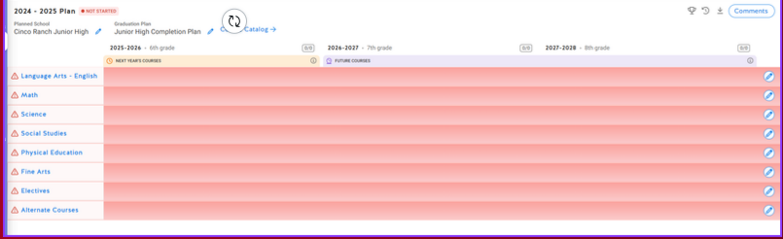
The course planner will pop up and this is where you will enter classes.

